1. class Solution {
public int maxSubArray(int[] nums) {
int maxSoFar = nums[0]; // best sum found so far
int currentSum = nums[0]; // current running sum
for (int i = 1; i < nums.length; i++) {
// either extend the current subarray or start new from nums[i]
currentSum = Math.max(nums[i], currentSum + nums[i]);
maxSoFar = Math.max(maxSoFar, currentSum);
}
return maxSoFar;
}
}
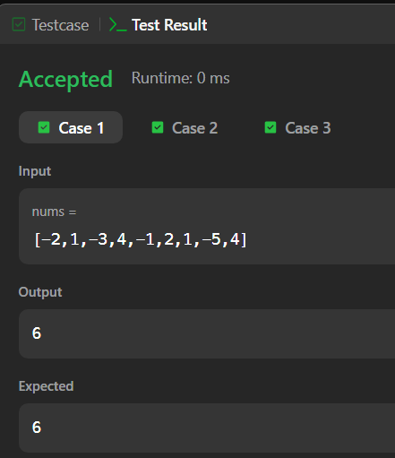

2. import java.util.*;
public class Solution {
static int birthday(List<Integer> s, int d, int m) {
int count = 0;
// Loop through possible starting points
for (int i = 0; i <= s.size() - m; i++) {
int sum = 0;
// Sum the next m elements
for (int j = 0; j < m; j++) {
sum += s.get(i + j);
}
if (sum == d) {
count++;
}
}
return count;
}
public static void main(String[] args) {
Scanner sc = new Scanner(System.in);
int n = sc.nextInt(); // number of squares
List<Integer> s = new ArrayList<>();
for (int i = 0; i < n; i++) {
s.add(sc.nextInt());
}
int d = sc.nextInt(); // Ron's birth day
int m = sc.nextInt(); // Ron's birth month
sc.close();
int result = birthday(s, d, m);
System.out.println(result);
}
}
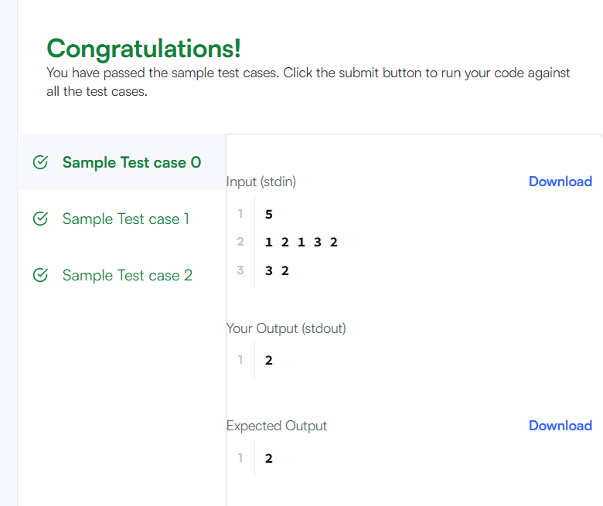

3. import java.util.*;
public class Solution {
static int[] maxSubarray(int[] arr) {
int n = arr.length;
int maxEndingHere = arr[0];
int maxSoFar = arr[0];
for (int i = 1; i < n; i++) {
maxEndingHere = Math.max(arr[i], maxEndingHere + arr[i]);
maxSoFar = Math.max(maxSoFar, maxEndingHere);
}
int subsequenceSum = 0;
int maxElement = arr[0];
for (int x : arr) {
if (x > 0) {
subsequenceSum += x;
}
maxElement = Math.max(maxElement, x);
}
if (subsequenceSum == 0) {
subsequenceSum = maxElement;
}
return new int[]{maxSoFar, subsequenceSum};
}
public static void main(String[] args) {
Scanner sc = new Scanner(System.in);
int t = sc.nextInt(); // number of test cases
while (t-- > 0) {
int n = sc.nextInt();
int[] arr = new int[n];
for (int i = 0; i < n; i++) {
arr[i] = sc.nextInt(); // must include ()
}
int[] result = maxSubarray(arr);
System.out.println(result[0] + " " + result[1]);
}
sc.close();
}
}
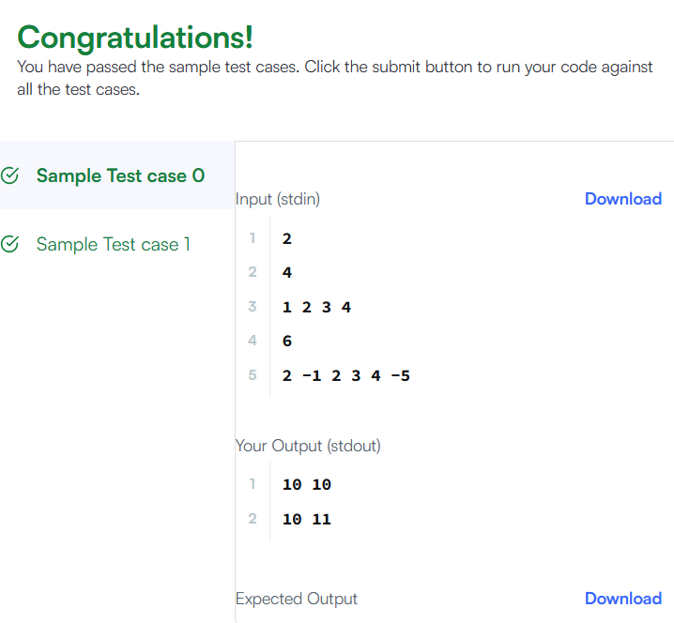

4. import java.util.*;
public class Solution {
public int maxSubarraySumCircular(int[] nums) {
int total = 0;
int maxEndingHere = nums[0], maxSoFar = nums[0];
int minEndingHere = nums[0], minSoFar = nums[0];
for (int i = 0; i < nums.length; i++) {
int x = nums[i];
total += x;
if (i > 0) {
// Kadane for max subarray
maxEndingHere = Math.max(x, maxEndingHere + x);
maxSoFar = Math.max(maxSoFar, maxEndingHere);
minEndingHere = Math.min(x, minEndingHere + x);
minSoFar = Math.min(minSoFar, minEndingHere);
}
}
if (maxSoFar < 0) {
return maxSoFar;
}
return Math.max(maxSoFar, total - minSoFar);
}
public static void main(String[] args) {
Scanner sc = new Scanner(System.in);
int n = sc.nextInt();
int[] nums = new int[n];
for (int i = 0; i < n; i++) {
nums[i] = sc.nextInt();
}
sc.close();
Solution sol = new Solution();
System.out.println(sol.maxSubarraySumCircular(nums));
}
}
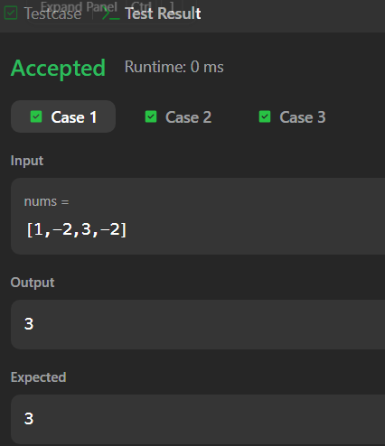

5. public class Solution {
public int myAtoi(String s) {
if (s == null || s.length() == 0) return 0;
int i = 0, n = s.length();
while (i < n && s.charAt(i) == ' ') {
i++;
}
int sign = 1;
if (i < n && (s.charAt(i) == '+' || s.charAt(i) == '-')) {
sign = (s.charAt(i) == '-') ? -1 : 1;
i++;
}
long result = 0;
while (i < n && Character.isDigit(s.charAt(i))) {
result = result * 10 + (s.charAt(i) - '0');
if (sign == 1 && result > Integer.MAX_VALUE) {
return Integer.MAX_VALUE;
}
if (sign == -1 && -result < Integer.MIN_VALUE) {
return Integer.MIN_VALUE;
}
i++;
}
return (int) result * sign;
}
public static void main(String[] args) {
Solution sol = new Solution();
System.out.println(sol.myAtoi("42")); // 42
System.out.println(sol.myAtoi(" -042")); // -42
System.out.println(sol.myAtoi("1337c0d3")); // 1337
System.out.println(sol.myAtoi("0-1")); // 0
System.out.println(sol.myAtoi("words and 987"));// 0
System.out.println(sol.myAtoi("-91283472332")); // -2147483648
}
}
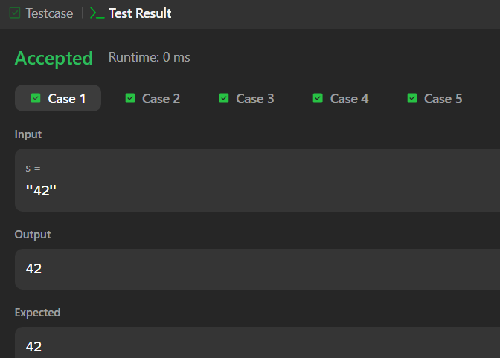

6. import java.util.*;
public class Solution {
static int alternatingCharacters(String s) {
int deletions = 0;
for (int i = 0; i < s.length() - 1; i++) {
if (s.charAt(i) == s.charAt(i + 1)) {
deletions++;
}
}
return deletions;
}
public static void main(String[] args) {
Scanner sc = new Scanner(System.in);
int q = sc.nextInt(); // number of queries
while (q-- > 0) {
String s = sc.next();
System.out.println(alternatingCharacters(s));
}
sc.close();
}
}

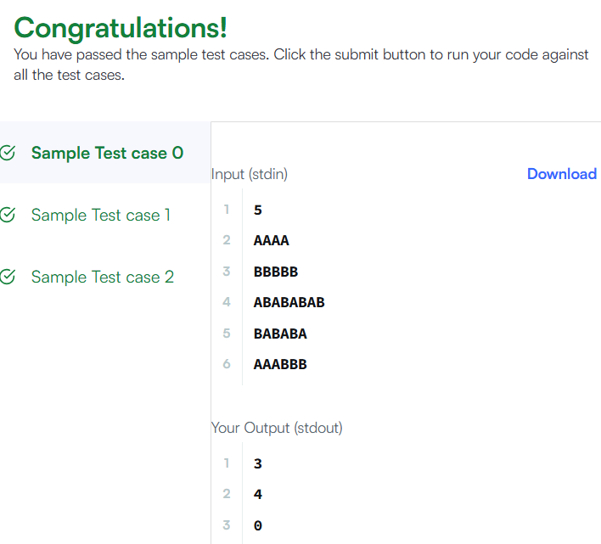

7. import java.util.*;
public class Solution {
public int lengthOfLongestSubstring(String s) {
Set<Character> seen = new HashSet<>();
int left = 0, maxLen = 0;
for (int right = 0; right < s.length(); right++) {
char c = s.charAt(right);
while (seen.contains(c)) {
seen.remove(s.charAt(left));
left++;
}
seen.add(c);
maxLen = Math.max(maxLen, right - left + 1);
}
return maxLen;
}
public static void main(String[] args) {
Solution sol = new Solution();
System.out.println(sol.lengthOfLongestSubstring("abcabcbb")); // 3
System.out.println(sol.lengthOfLongestSubstring("bbbbb")); // 1
System.out.println(sol.lengthOfLongestSubstring("pwwkew")); // 3
}
}
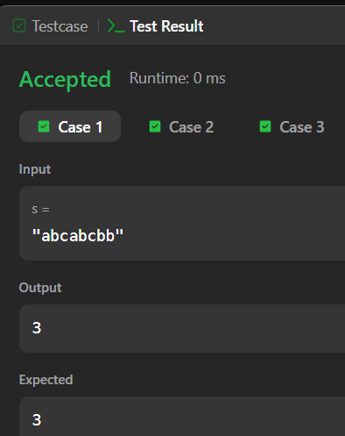

8. import java.util.*;
public class Solution {
public List<String> findAndReplacePattern(String[] words, String pattern) {
List<String> result = new ArrayList<>();
for (String word : words) {
if (matches(word, pattern)) {
result.add(word);
}
}
return result;
}
private boolean matches(String word, String pattern) {
if (word.length() != pattern.length()) return false;
Map<Character, Character> pToW = new HashMap<>();
Map<Character, Character> wToP = new HashMap<>();
for (int i = 0; i < word.length(); i++) {
char w = word.charAt(i);
char p = pattern.charAt(i);
if (pToW.containsKey(p) && pToW.get(p) != w) return false;
if (wToP.containsKey(w) && wToP.get(w) != p) return false;

pToW.put(p, w);
wToP.put(w, p);
}
return true;
}
public static void main(String[] args) {
Solution sol = new Solution();
String[] words = {"abc","deq","mee","aqq","dkd","ccc"};
String pattern = "abb";
System.out.println(sol.findAndReplacePattern(words, pattern)); // [mee, aqq]
}
}
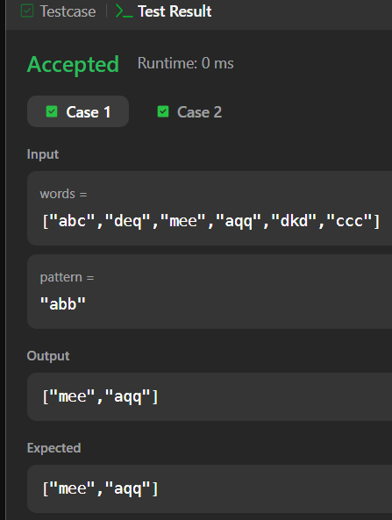

9. import java.util.*;
public class Solution {
public List<String> stringMatching(String[] words) {
List<String> result = new ArrayList<>();
for (int i = 0; i < words.length; i++) {
for (int j = 0; j < words.length; j++) {
if (i != j && words[j].contains(words[i])) {
result.add(words[i]);
break; // avoid duplicates
}
}
}
return result;
}
public static void main(String[] args) {
Solution sol = new Solution();
String[] words1 = {"mass","as","hero","superhero"};
System.out.println(sol.stringMatching(words1)); // [as, hero]
String[] words2 = {"leetcode","et","code"};
System.out.println(sol.stringMatching(words2)); // [et, code]
String[] words3 = {"blue","green","bu"};
System.out.println(sol.stringMatching(words3)); // []
}
}
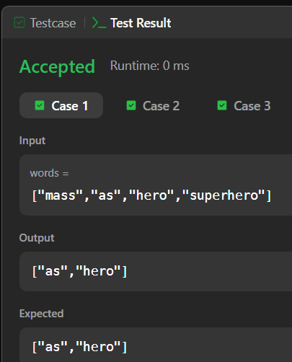
10. import java.util.*;
public class NaivePatternSearch {
public static List<Integer> search(String text, String pattern) {
List<Integer> result = new ArrayList<>();
int n = text.length();
int m = pattern.length();
for (int i = 0; i <= n - m; i++) {
int j;
for (j = 0; j < m; j++) {
if (text.charAt(i + j) != pattern.charAt(j)) {
break;
}
}
if (j == m) {
result.add(i); // match found at index i
}
}
return result;
}
public static void main(String[] args) {
System.out.println(search("geeksforgeeks", "geeks"));
// Output: [0, 8]
System.out.println(search("aabaacaadaabaaba", "aaba"));
// Output: [0, 9, 12]
}
}
